[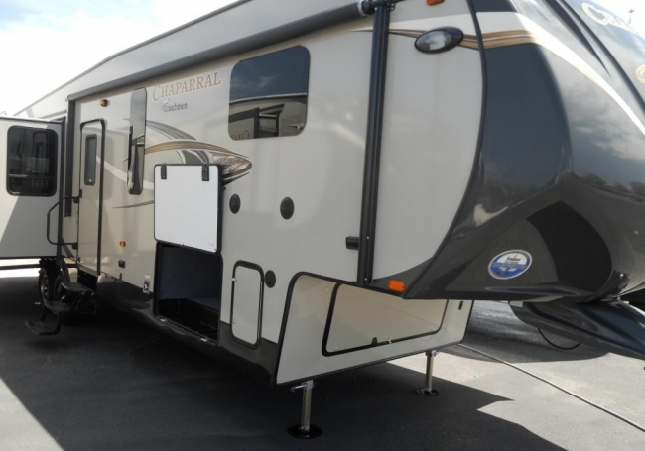](http://www.crossroads-rv.com/console/watermark_large.php?src=7299)